**School Website Templet Overview**

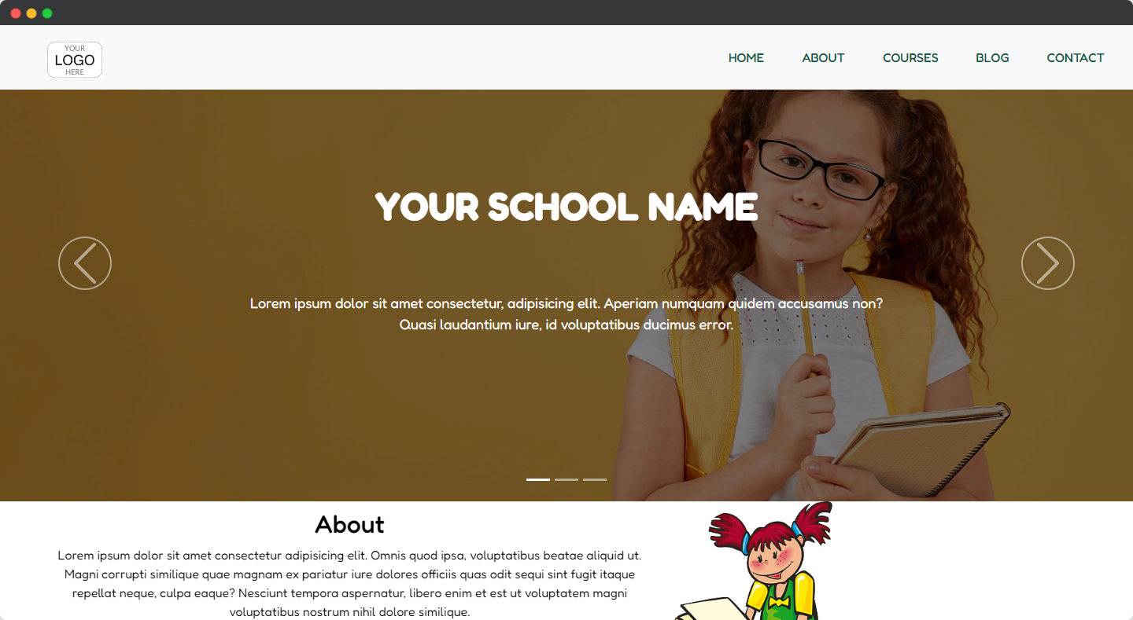

**Larch Soft Pvt. Ltd.** has crafted a fantastic website template that is tailor-made for **schools.** With a sleek and modern design, this template is fully responsive, which means it looks great and functions perfectly on any device. Visitors will love the easy-to-use interface and intuitive navigation that makes finding the information they need a breeze.

**Looks Fantastic On Every Screen Size**

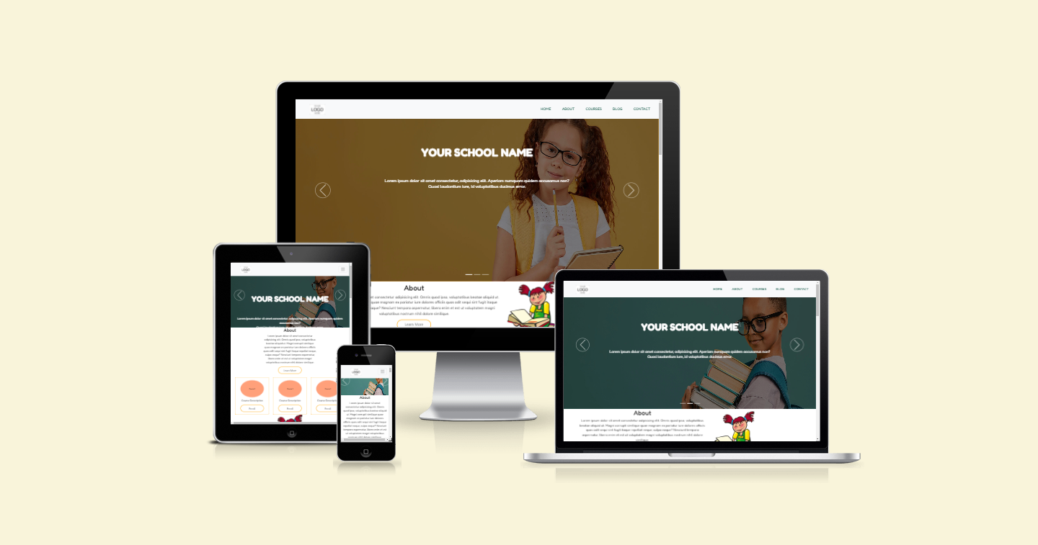

**Showcase You School Events**

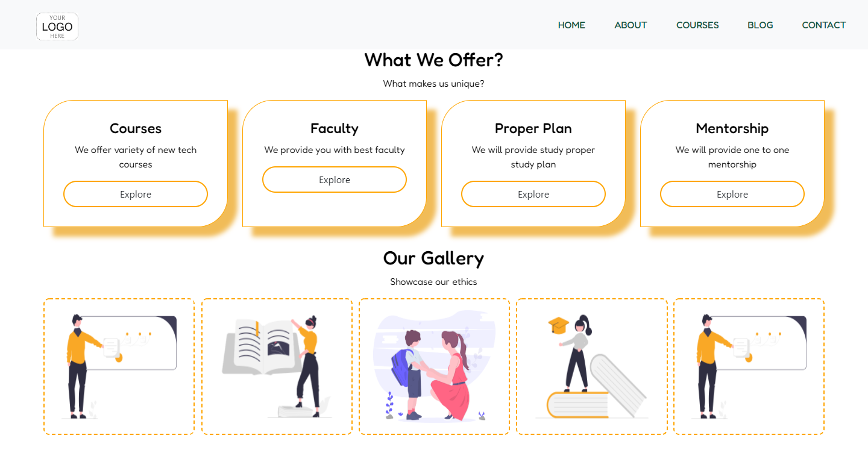

The **gallery section** is another exciting feature that sets this template apart. You can showcase images of your school's facilities, events, and activities, giving visitors a glimpse into the unique and special aspects of your school.

**Easy To Contact**

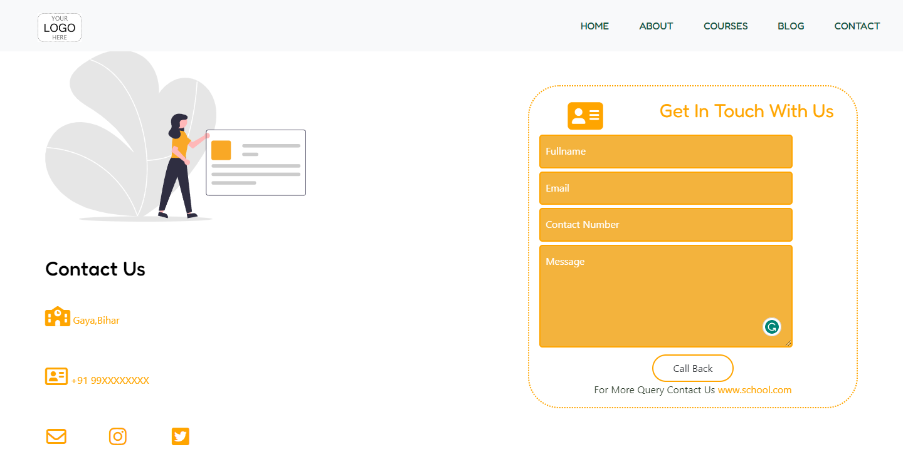

One of the standout features of this template is the **contact form**, which lets visitors easily connect with your school. Whether they want to ask a question, provide feedback, or simply say hello, the contact form makes it simple and hassle-free.

**It’s Free**

This free website template is a fantastic opportunity for schools to showcase their values, mission, and achievements in a professional and visually stunning way. It's a powerful tool that can help your school standout online and attract more students and visitors.

Larch Soft Pvt. Ltd. is delighted to offer this template as a gift to schools looking to create a strong online presence. We believe that every school should have the opportunity to represent themselves in the best possible light, and this template is our way of helping schools achieve that goal.